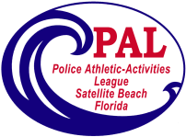
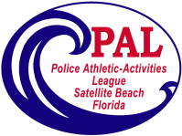
Satellite Beach PAL Volleyball
Fall 2021

Registration Begins August 2, 2021
Skill Assessments August 22, 2020 @2:00pm
Games Begin on Saturday September 25, 2021
Photos by Skip Combs October 9, 2021

For girls 10-16 years of age
The season begins September 25 – December 4
Playoffs begin December 7
The cost for this season is $95
Need more information, please contact us at:
321-777-8336
Pal@satellitebeach.org

