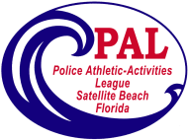
Satellite Beach PAL Spring Volleyball
2020

David Schechter Community Center
10-16 year olds - $85.00
Ages calculated as of 3/7/2020

Sign up dates:
Wednesday afternoons 4:00-6:00pm
Friday evenings ~ 4:30 – 6:30pm

Or you may leave your paperwork at the Rec Dept.

Assessments

February 9th 1:00pm

All registrations received after February 9th will be subject to a

$10 late fee ________________________________________________

Skip Combs Photography

Team Photographs
Saturday, March 28th

*** All coaches and assistant coaches***
1. Complete & return a volunteer form
2. Sign and register a “Code of Conduct”

Spring Season begins ~ March 7th
Tournament begins ~ May 17th

Please note: any refund requests after skill assessments will result in a $10.00 administration charge
If you have any questions, please feel free to contact
Satellite Beach PAL ~ 777-8336
Or visit our web site ~ www.satellitebeachpal.org

