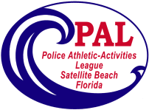
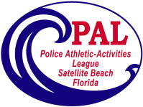
Satellite Beach PAL Volleyball
Fall 2022

Registration Begins July 11, 2022
Skill Assessments August 14, 2022 @1:00pm
Practices begin August 30, 2022
Games Begin on Saturday September 10, 2022
Photos by Skip Combs September 24, 2022
Additional Sunday games September 25 & October 16

For girls 10-16 years of age
The season begins September 10 – October 29
Playoffs begin October 30
The cost for this season is $95
Need more information, please contact us at:
321-777-8336
Pal@satellitebeach.org

